
Teacher Reflection and Growth Plan
Template Reference Document
www.iabacus.com

Introduction
This document provides a full reference for the iAbacus Teacher Reflection and Growth Plan template, designed for use by teachers and teacher-leaders in schools and educational settings across the UK and beyond.
The template supports professional reflection, evidence gathering, and action planning as part of a continuous cycle of professional development and performance management. It is designed to be used within the iAbacus platform, which provides a structured, intuitive digital environment for self-evaluation.

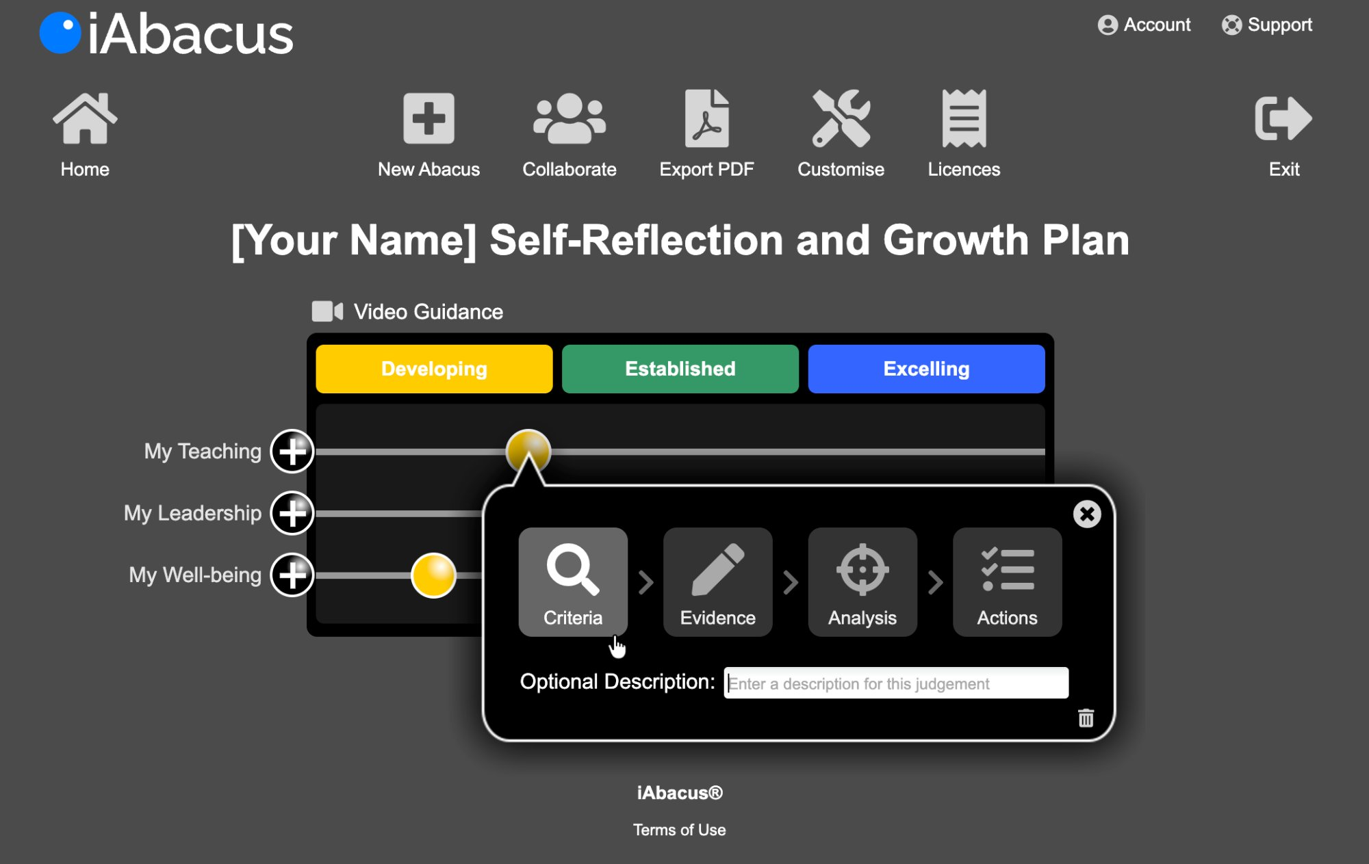

How the Template Works
The template is built around three Areas of professional practice. Each Area is represented on screen as a bead on a track. Teachers position their bead to indicate their current level of performance across three levels:

Developing | Established | Excelling

Once a teacher has positioned their bead, they click through a four-step process for each Area:

Criteria | Evidence | Analysis | Actions
The teacher reviews the criteria for their chosen level and moderates their judgement accordingly. | The teacher describes the evidence that best demonstrates their current level of practice, with the option to attach files or web links. | The teacher identifies the factors — people, resources, circumstances — that are currently helping or hindering their practice. | The teacher plans specific actions to strengthen what is helping and address what is hindering their practice.

Template Versions
The template is available in two versions to reflect the different responsibilities of teaching staff:

Version | Areas included
Version 1 — Teacher with Leadership Responsibility | My Teaching / My Leadership / My Well-being
Version 2 — Classroom Teacher | My Teaching / My Well-being

A bespoke school improvement focus Area will be added to both versions at a later stage.

Criteria Structure
Each Area and level contains the following elements:
- An opening statement describing how the teacher feels about their practice at that level.
- An impact statement describing the effect on students, team or personal well-being.
- A set of bullet point criteria describing the observable behaviours and actions at that level.
- A footnote definition clarifying key terms, intentionally broad to ensure the template works across different national contexts, including England, Scotland, Wales and Northern Ireland.

Area 1: My Teaching
Reflecting on the quality of my teaching and its impact on student learning and progress.

Developing
I am developing my teaching practice and working towards meeting the expected *professional standards.
I am developing my understanding of **expectations for student learning and how to assess progress against them.
- I am reviewing the *professional standards and evaluating my teaching against them.
- I am clarifying **expectations for student learning and beginning to assess progress against them.
- I am identifying aspects of my teaching I want to develop and improve.
- I am identifying professional development priorities in discussion with colleagues.
- I am engaging with my performance management process to support my development.
*professional standards imply: relevant guidance and criteria for the quality of teaching and learning including: school/setting specifications; national standards and professional values.
**expectations for student learning imply: relevant attainment levels, or standards of learning, used to compare student progress, in school, locally and nationally.

Established
I am confident that my teaching meets the expected *professional standards, or I have clear plans in place to ensure it does.
My students meet **expectations for student learning, or I have clear plans in place to ensure they do.
- I have a consistent process of self-evaluation and professional development in place.
- I regularly review relevant guidance and criteria for the quality of teaching and learning.
- I collect a range of evidence demonstrating that my teaching meets expected standards.
- I collaborate with colleagues to develop and sustain effective teaching practice.
- I update my professional planning regularly to reflect my self-evaluation.
*professional standards imply: relevant guidance and criteria for the quality of teaching and learning including: school/setting specifications; national standards and professional values.
**expectations for student learning imply: relevant attainment levels, or standards of learning, used to compare student progress, in school, locally and nationally.

Excelling
I am confident that my teaching meets, or exceeds, the expected *professional standards in most, if not all, aspects of my practice.
My students consistently meet or exceed **expectations for student learning.
- I collect compelling evidence of the positive impact of my teaching on student learning, drawing on regular reviews by myself and colleagues.
- I engage proactively with professional development to ensure my practice evolves as expectations change.
- I lead a cyclical process of analysis, planning and review to sustain the highest levels of performance.
- I take an active role in sharing good practice within and beyond my school.
- I use evidence of student outcomes to continuously refine my planning and professional practice.
*professional standards imply: relevant guidance and criteria for the quality of teaching and learning including: school/setting specifications; national standards and professional values.
**expectations for student learning imply: relevant attainment levels, or standards of learning, used to compare student progress, in school, locally and nationally.

Area 2: My Leadership
Reflecting on the quality of my leadership and its impact on my team and school.
Note: This Area is included in Version 1 of the template, for teachers with a leadership responsibility.

Developing
I am developing my understanding of my leadership role and working towards meeting the *agreed standards and criteria.
The team or area I lead is beginning to develop in line with expectations.
- I am working to understand my leadership responsibilities and the criteria associated with my role.
- I am beginning to evaluate the impact of my leadership on the team and the wider school.
- I am identifying the aspects of my leadership role that most need attention and development.
- I am starting to work collaboratively with colleagues to better understand and meet expectations.
*agreed standards and criteria imply: those selected and expected including: school/setting specifications; national standards and personal/professional values.

Established
I am confident that I meet the *agreed standards and criteria for my leadership role, or I have clear plans in place to ensure I do.
The team or area I lead is performing in line with expectations.
- I understand and consistently apply the criteria relevant to my leadership role.
- I regularly monitor and evaluate the impact of my own work and that of the team against agreed criteria.
- I am building a clear body of evidence of our impact, particularly in priority areas.
- I work collaboratively with colleagues on agreed priorities for improvement, within my area and across the school.
*agreed standards and criteria imply: those selected and expected including: school/setting specifications; national standards and personal/professional values.

Excelling
I am confident that my leadership meets, or exceeds, the *agreed standards and criteria for my role.
The team or area I lead consistently meets or exceeds expected results, outcomes and impact measures.
- I have a thorough understanding of the criteria for my role and use them consistently to drive improvement.
- I lead a cyclical process of review, analysis and planning to sustain the highest levels of effectiveness.
- I have compelling evidence that leadership within my area meets or exceeds all expected criteria.
- I collaborate with colleagues and senior leaders to develop and sustain excellent leadership practice within and beyond school.
*agreed standards and criteria imply: those selected and expected including: school/setting specifications; national standards and personal/professional values.

Area 3: My Well-being
Reflecting on my well-being and its impact on my professional practice and personal life.

Developing
There are good days and not so good days. When asked how I am, I often describe myself as “Fine” or “OK”, whilst recognising that aspects of my well-being could be improved.
My current level of well-being is beginning to affect my performance.
- I am exploring *aspects of well-being and beginning to understand their effect on me.
- I recognise the need to improve my work-life balance.
- I am beginning to put together a plan and identify activities to improve my well-being.
- I am beginning to talk to family, friends and colleagues about well-being.
*aspects of well-being include: mental and physical health; diet; fitness; relationships and work-life balance.

Established
Most of the time I feel well and am doing well. If not, I am fairly confident I know why and am working on strategies to improve my well-being.
My improving level of well-being is having a positive effect on my performance.
- I am considering most *aspects of well-being and identifying how I can maximise their positive effects on me.
- My work-life balance is improving.
- I have plans and activities in place to support and improve my well-being.
- I have family, friends and colleagues with whom I can discuss well-being issues openly and honestly.
*aspects of well-being include: mental and physical health; diet; fitness; relationships and work-life balance.

Excelling
I am confident that my well-being is excellent. I have a strong sense that all is well and well-developed strategies to deal with the challenges I face.
My high level of well-being sustains my performance and supports those around me.
- I am fully aware of all *aspects of well-being and how they affect me, or might do so in the future.
- My work-life balance is excellent.
- My well-being plans and activities are in place and working well.
- I am fully open about well-being with family, friends and colleagues, and we provide each other with excellent support.
*aspects of well-being include: mental and physical health; diet; fitness; relationships and work-life balance.

Example Focus Area: My Focus — Literacy Across the Curriculum
This is an example of a bespoke school improvement focus Area, designed for use in secondary schools as an addition to the core template. It works for both classroom teachers and teachers with leadership responsibility.
Focus Areas are designed to reflect a school’s current improvement priorities and can be updated each year to reflect changing needs.

Developing
I am developing my understanding of how literacy can be embedded in my teaching and, where relevant, across my area of responsibility.
My students are beginning to benefit from a more consistent approach to literacy in my lessons.
- I am developing my understanding of what literacy across the curriculum means in my subject or phase.
- I am identifying opportunities to embed reading, writing, oracy or vocabulary development into my lessons.
- I am beginning to use *agreed literacy strategies consistently in my teaching.
- I am exploring how colleagues approach literacy in their subjects and beginning to share ideas.
*agreed literacy strategies imply: those identified and prioritised by the school, which may include approaches to vocabulary instruction, extended writing, reading for meaning, oracy and disciplinary literacy.

Established
I am confident that literacy is embedded in my teaching practice and, where relevant, across my area of responsibility.
My students demonstrate improved literacy skills and are able to apply them confidently within my subject.
- I consistently embed *agreed literacy strategies into my planning and teaching.
- I regularly assess how effectively students are developing literacy skills within my subject.
- I collect evidence of the impact of literacy approaches on student progress and outcomes.
- I collaborate with colleagues to develop and share effective literacy strategies across the curriculum.
*agreed literacy strategies imply: those identified and prioritised by the school, which may include approaches to vocabulary instruction, extended writing, reading for meaning, oracy and disciplinary literacy.

Excelling
I am confident that literacy is a strength of my practice and, where relevant, a priority that drives improvement across my area of responsibility and the wider school.
My students consistently demonstrate strong literacy skills that support their achievement across subjects.
- I have compelling evidence of the positive impact of literacy strategies on student outcomes in my subject.
- I lead or actively contribute to a cyclical process of review and development of literacy across the curriculum.
- I model and share excellent literacy practice within and beyond my team or department.
- I work with colleagues and senior leaders to sustain and develop a whole-school culture of literacy.
*agreed literacy strategies imply: those identified and prioritised by the school, which may include approaches to vocabulary instruction, extended writing, reading for meaning, oracy and disciplinary literacy.

Why use iAbacus for Teacher and Leader Reflection and Growth?

A tool that puts teachers and leaders in control
Too often, professional development and performance management are done to teachers and leaders rather than with them. iAbacus changes that. By starting with the individual's own judgement and building outward from there, it puts professional growth firmly in the hands of the person who matters most — the teacher or leader themselves.

A process that makes reflection meaningful
The four-step Criteria → Evidence → Analysis → Actions process ensures that reflection doesn't stop at self-assessment. It moves teachers and leaders through a structured journey from honest judgement to tangible action, creating a continuous cycle of improvement rather than a one-off annual exercise.

A template designed for the whole professional
By addressing teaching practice, leadership and well-being in a single, integrated tool, the template recognises that professional performance cannot be separated from personal sustainability. A teacher who is struggling with well-being cannot fully excel in the classroom, and a leader who lacks clarity about their role cannot effectively support their team.

Connected to school improvement priorities
The bespoke focus Area allows schools to align individual teacher and leader reflection directly with whole-school improvement priorities. Whether the focus is literacy, behaviour, assessment or curriculum design, every teacher and leader reflects on the same shared priority — creating a powerful thread between personal professional development and the wider direction of the school.

Built for every context
The template is intentionally universal. Whether a teacher or leader works in England, Scotland, Wales or Northern Ireland — or beyond — the criteria and footnote definitions are designed to flex around local standards, frameworks and expectations without losing their coherence or purpose.

Evidence that works for you
The ability to attach files, add web links and export a polished PDF report means that the iAbacus process generates genuine, usable evidence for performance management conversations — not a bureaucratic exercise, but a professional dialogue built on real reflection.

Find out more at www.iabacus.com

